SHOP ONLINE FOR VETERANS CRUISE LOGO APPAREL FROM QUEENSBORO APPAREL CO.

Please Login – MOAA Store (qbstores.com)

Step 1. Begin by Registering for your personal account.
That will open an online store with available logo apparel for our cruise.

Step 2. When you see an item that interests you, select it.

Step 3. Then insert a number in the box next to size and color for the quantity desired. That action will send it to your cart.

Options.
Step 1. Additional shopping is an option.

Step 2. When you are ready for checkout, you will be asked for shipping and billing address plus credit/debit card info.
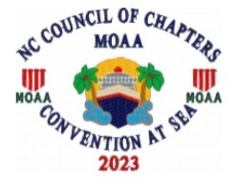

Logo for the cruise will be embroidered on all items you select.

If you need help with the ordering, suggest you send an email to Queensboro at https://www.queensboro.com or you can call Ken Klassen, VP-1 for NCCOC at
910-616-9614..

Guests will receive berthing info, details for final payment and other details later this spring from AAA Travel agent Lorna Tiller. She can be contacted by email: ltillertravels@gmail.com or ph. 910-540-3390. It is shaping up to be a major social event in November. Dress to impress, sell the MOAA brand and wave the Flag!!

Bon Voyage

